Day 29 (30 August 2025)
112552596 - vsisukhw - Sukhwinder Singh

For tasks questions , refer
https://docs.google.com/document/d/1fMTvhxItCyxONzLyU6TITkzWo7kkHVKiZCKXtBszbcA/edit?tab=t.0

Task 1 and 2

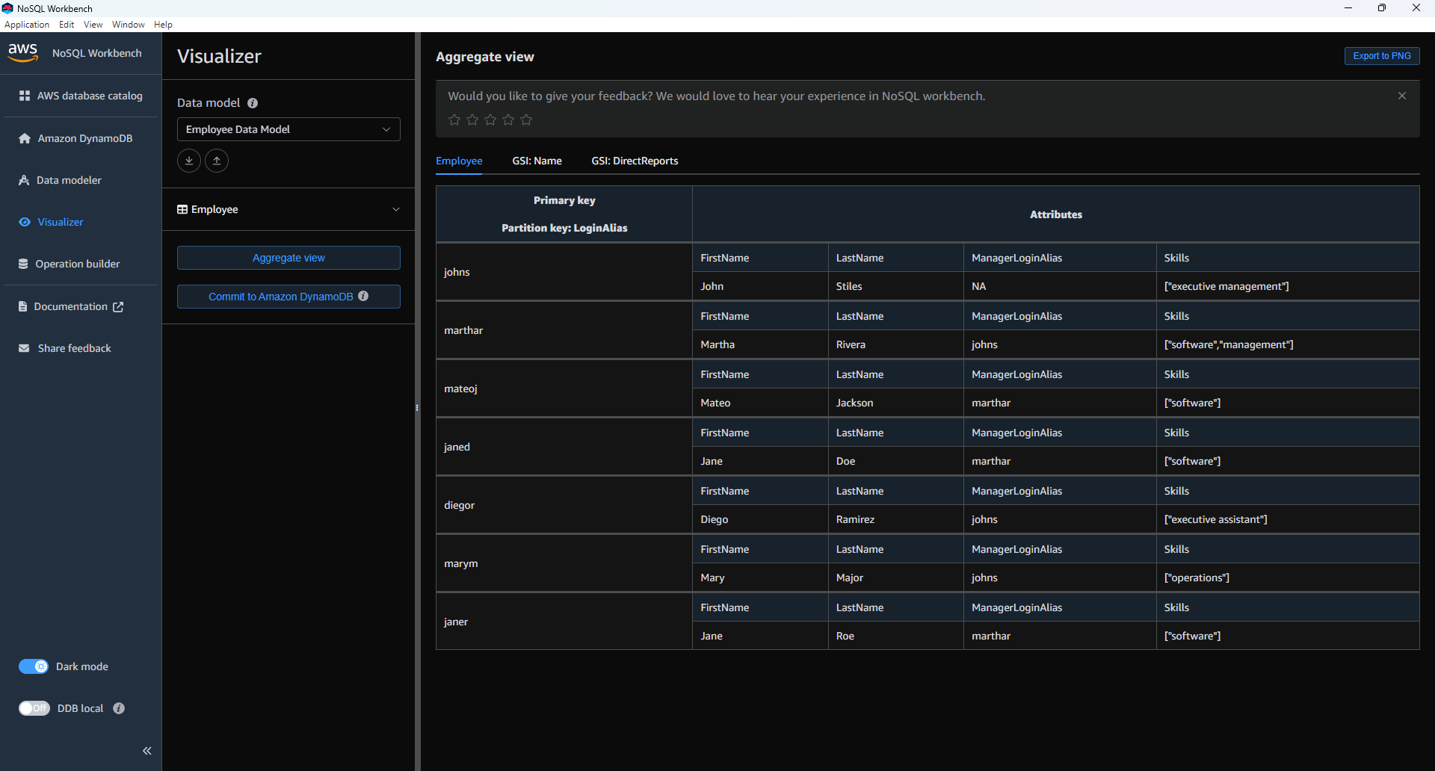

Task 3

